To generate client proxy use metadata at http://localhost:8081/SmartScheduleWCFService/mex Test service instance C:\SmartSchedule.NET\ServiceTest\SmartSchedule.Service.exe should be running. Sample client project (VS2005) is located in C:\SmartSchedule.NET\ServiceTest\ SimpleWebClient

Retreiving technician daily settings

IEnumerable<Technician> GetDefaultTechniciansWeb() – gets all the technicians with their default settings

List<TechnicianDetail> GetTechnicianDetailsByServmanIdWeb(string technicianServmanId, bool defaultSettings),
List<TechnicianDetail> GetTechnicianDetailsWeb(int technicianDefaultId, bool defaultSettings) -
Gets technician details (settings) for specified technician. Technician can be specified by technicianServmanId which is techmast.tech_id or by technicianDefaultId which is Technician.TechnicianDefaultId, where Technician retrieved using GetDefaultTechnicians(). DefaultSettings – when this parameter is set to true – system returns dafault technician setting (only 1 record in collection) which is used as base setting to create new daily settings.

These methods gets all the technician settings for dates from now without restrictions for future dates.

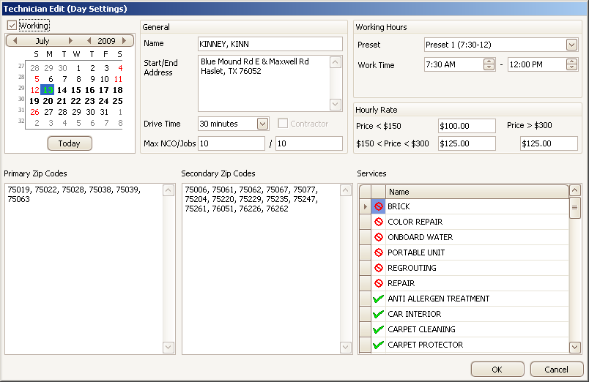

TechnicianDetail explanation:

detail.Technician.ScheduleDate – technician working date
detail.Technician.Name – technician name
detail.Technician.DepotAddress – start/end address
detail.Technician.DriveTimeMinutes – drive time in minutes
detail.Technician.IsContractor – if true – contractor, false - franchisee
detail.Technician.MaxNonExclusiveVisitsCount – max NCO
detail.Technician.MaxVisitsCount – Max jobs
detail.WorkingHoursPresets – technician personal working hours presets, used to speed-up working time setup
detail.WorkingHoursPresets[i].PresetNumber – sequence number
detail.WorkingHoursPresets[i].TimeStart – preset start time
detail.WorkingHoursPresets[i].TimeEnd – preset end time
detail.Technician.WorkingIntervals – specifies working time (Work Time on UI) intervals. Currently has only 1 item in collection
detail.Technician.WorkingIntervals[i].TimeStart – work time start
detail.Technician.WorkingIntervals[i].TimeEnd – work time end
detail.Technician.HourlyRate – hourly rate
detail.Technician.HourlyRate150to300
detail.Technician.HourlyRateMore300
detail.Technician.PrimaryZipCodes – zip codes (collection of strings)
detail.Technician.SecondaryZipCodes – zip codes (collection of strings)
detail.PrimaryZipCodesText
detail.SecondaryZipCodesText – single string zip codes representation
detail.Services – collection of technician services
detail.Services[i].Name – service name
detail.Services[i].ServiceAllowance – service allowance. NotAllowed (cannot do), Allowed (can do), AllowedForExclusive (can do on exclusive tickets only)

Saving technician daily settings

List<TechnicianDetailValidationError> SaveTechnicianDetailWeb(List<TechnicianDetail> affectedTechnicians, List<DateTime> removedDates, int defaultTechnicianId);
– saves technician settings. Returns collection of errors. If collection is not empty changes are not saved

List<TechnicianDetail> affectedTechnicians – collection of modified and newly created settings.
List<DateTime> removedDates – collection of dates whose daily settings should be removed. Technician is not working that day.
TechnicianDetail.IsDirty – this property can be used on client to determine which settings were modified, and form affectedTechnicians collection. Server ignores this property. Collection of affectedTechnicians shouldn’t contain multiple items with the same detail.Technician.ScheduleDate. Modifications in detail.WorkingHoursPresets collection will be ignored.

List<TechnicianDetailValidationError> ValidateTechnicianDetailsWeb(
List<TechnicianDetail> affectedTechnicians, List<DateTime> removedDates,
int defaultTechnicianId, bool deepValidation)
– validates changes to notify user about errors. Method works just like SaveTechnicianDetail. deepValidation specifies whether geocoding validation should be done (depot address, zip codes). Deep validation should usually be done last (when user press Save) because it is more time consuming.

